Report Designer

The following report layout will be designed to be used in a later lab by an RPGLE program:

3/01/2011 14:24:55 Weekly Payroll Report Page:0001
Name: Student Name

Employee Work Pay Hourly Hours Regular Overtime Total
Number Shift Grade Rate Worked Pay Pay Pay

333-333-333 D 1 16.00 41 664.00 24.00 688.00

122-222-222 D 3 14.20 35 497.00 497.00

322-222-222 D 2 15.70 40 628.00 628.00

. . .

Totals: $28,685.69 $499.68 $29,185.37

This externally compiled printer file will be available to programs of all languages that print reports on the system.

The programmer will not have to provide the layout for the report. Instead they will just refer to the various types of output records available to them. They will write Title, ColHdg, EmpDetail and Totals.

Hopefully when you look at the report above, you can pick out those items.

The RDp GUI tool Report Designer will be used to develop your externally described printer file report.

Here is the code you will not be entering:

A R TITLE
A 1 45'Weekly Payroll Report'
A 1 89'Page:'
A 1 94PAGNBR
A 1 3DATE(*YY)
A EDTCDE(Y)
A 1 15TIME
A R COLHDG SPACEB(1)
A 6'Employee'
A SPACEB(1)
A 19'Work'
A 29'Pay'
A 37'Hourly'
A 47'Hours'
A 56'Regular'
A 71'Overtime'
A 89'Total'
A 7'Number'
A SPACEB(1)
A 19'Shift'
A 29'Grade'
A 38'Rate'
A 47'Worked'
A 58'Pay'
A 74'Pay'
A 90'Pay'
A R EMPDETAIL SPACEB(2)
A EMPNUM R 9S 0 5REFFLD(ALLSHIFT/EMPNUM SENECAPAY/A-
A LLSHIFT)
A EDTWRD('0 - - ')
A WORKSHIFT R 1A 20REFFLD(ALLSHIFT/WORKSHIFT +
A SENECAPAY/ALLSHIFT)
A PAYGRADE R 30REFFLD(ALLSHIFT/PAYGRADE +
A SENECAPAY/ALLSHIFT)
A HOURLYRATE 5 2 37EDTCDE(1)
A HRSWORKED R 48REFFLD(ALLSHIFT/HRSWORKED +
A SENECAPAY/ALLSHIFT)
A REGULARPAY 7 2 55EDTCDE(1)
A OVERPAY 7 2 70EDTCDE(1)
A TOTALPAY 7 2 86EDTCDE(1)
A R TOTALS SPACEB(2)
A 41'Totals:'
A TOTREGPAY 9 2 51
A EDTCDE(1 $)
A TOTOVTPAY 9 2 66EDTCDE(1 $)
A TOTEMPPAY 9 2 82EDTCDE(1 $)

Instead of entering code, open up RDp and create a source physical file called PayrollApp.

Create a new member in PayRollApp called PAYRPT and use the type PRTF (printer file)

Close this member and reopen it with Report Designer. Use the same technique that use used with Screen Designer to do this.

An absolute record is required first. You can create this by dragging Absolute Record from the left side Palette and releasing it in the work area. The default name for this is RECORD1. You can change this record name to TITLE in the Properties view on the lower right.

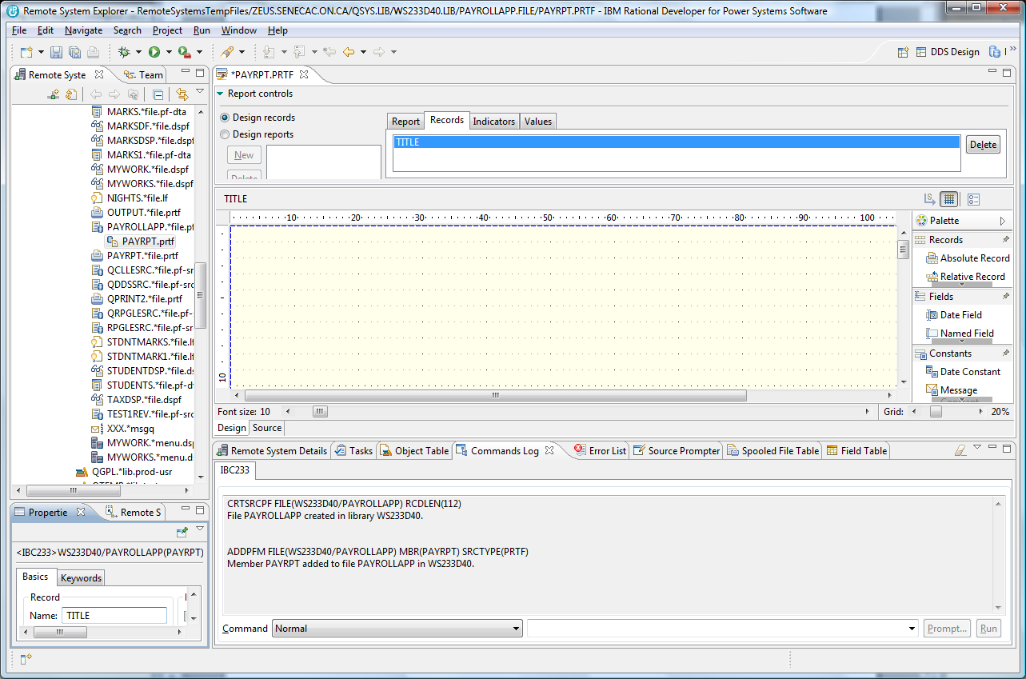

Double click on the PAYRPT.PRTF tab to get an expanded view of the palette. The content that needs to be added to the TITLE record includes a Date Constant, Time Constant, Text Constants and a Page Number Constant. All of this is found in the palette. You do not have to place everything in the exact column number that this report uses, but make it all visually fit between column 1 and column 100. Also include on the second line a Name label and your actual full name.

As you are working on this report, you can press CTRL+S occasionally to save your work.

There are Design and Source tabs available so you can look at the DDS code that is being generated.

The finished product shows on the next page for TITLE .

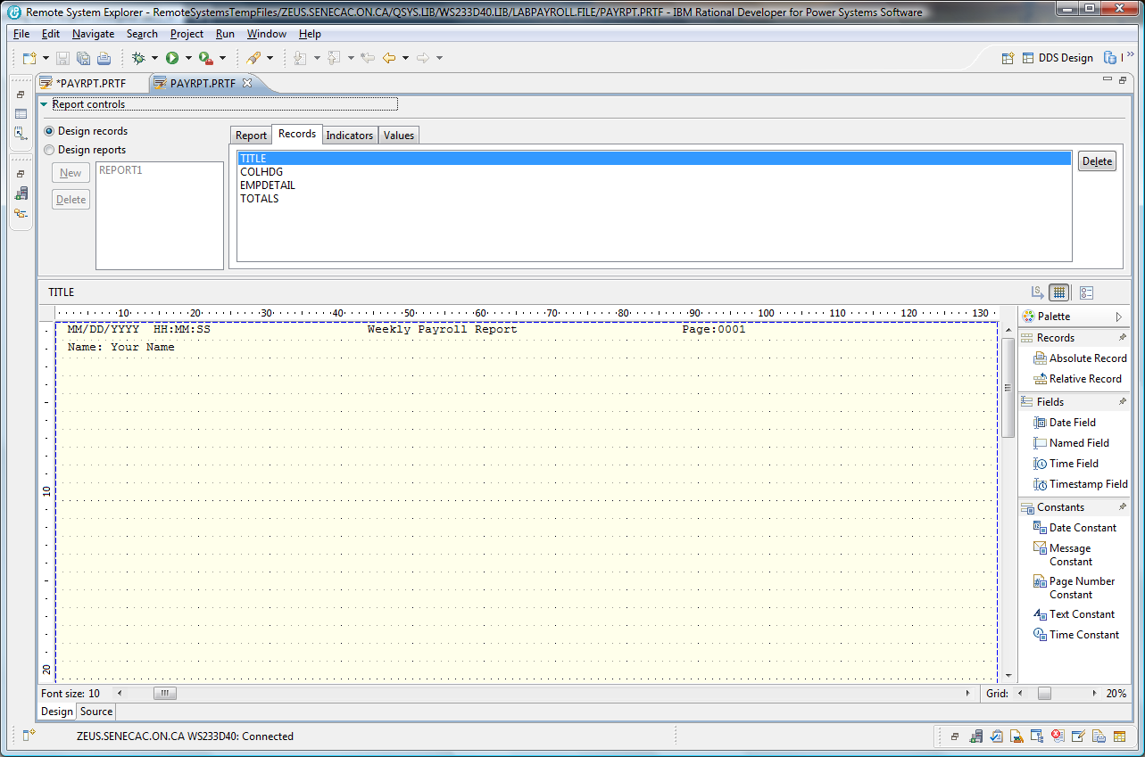

The next record you add from the palette should be a Relative Record called COLHDG. Drag this over and make sure you drop it on line 3 or 4. TITLE does not show, but you will be able to line everything up later when Designing Reports.

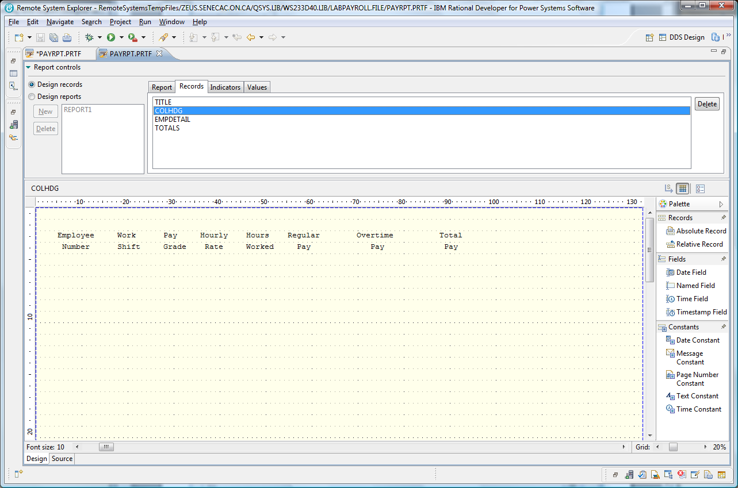

The EMPDETAIL relative record will have the fields from a file called ALLSHIFT in the SENECAPAY library dragged onto the screen on a line number lower than the column headings.

Notice in the screenshot below an object filter was created to the SENECAPAY library and the ALLSHIFT object. Then the ALLSHIFT.*file.pf-dta was right clicked on with a Show in Table – Fields selected for the field table.

Each field was dragged to an appropriate area on the screen and then the properties view was used to supply edit codes or edit words. An edit code of “2” was used on all the numeric fields except for the employee number.
An edit word was used for the employee number. Create named fields for HOURLYRATE, REGULARPAY, OVERPAY, and TOTALPAY.

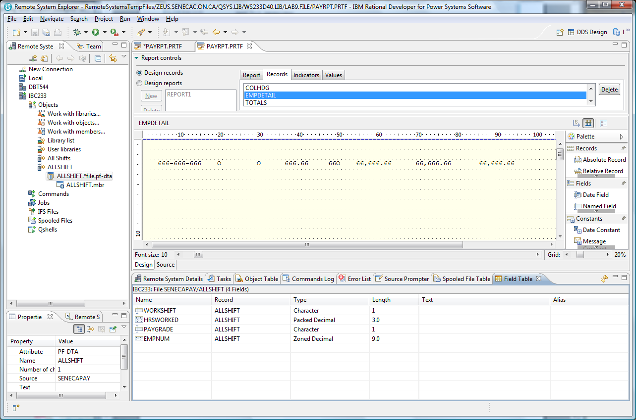

Provide a Totals record with named fields used for the last three column totals. TOTREGPAY, TOTOVTPAY and TOTEMPPAY. These fields are zoned numeric and 9 digits with 2 decimal places. These field also use an edit code of “1” and include the currency symbol.

You are now ready to put all this together. There is a report control area under the PAYRPT.PRTF tab at the upper right. It was set at Design records for this first stage.

Click on the Design reports radio button and click on the Report tab to change the name from untitled to Report1 and click on the Apply button.

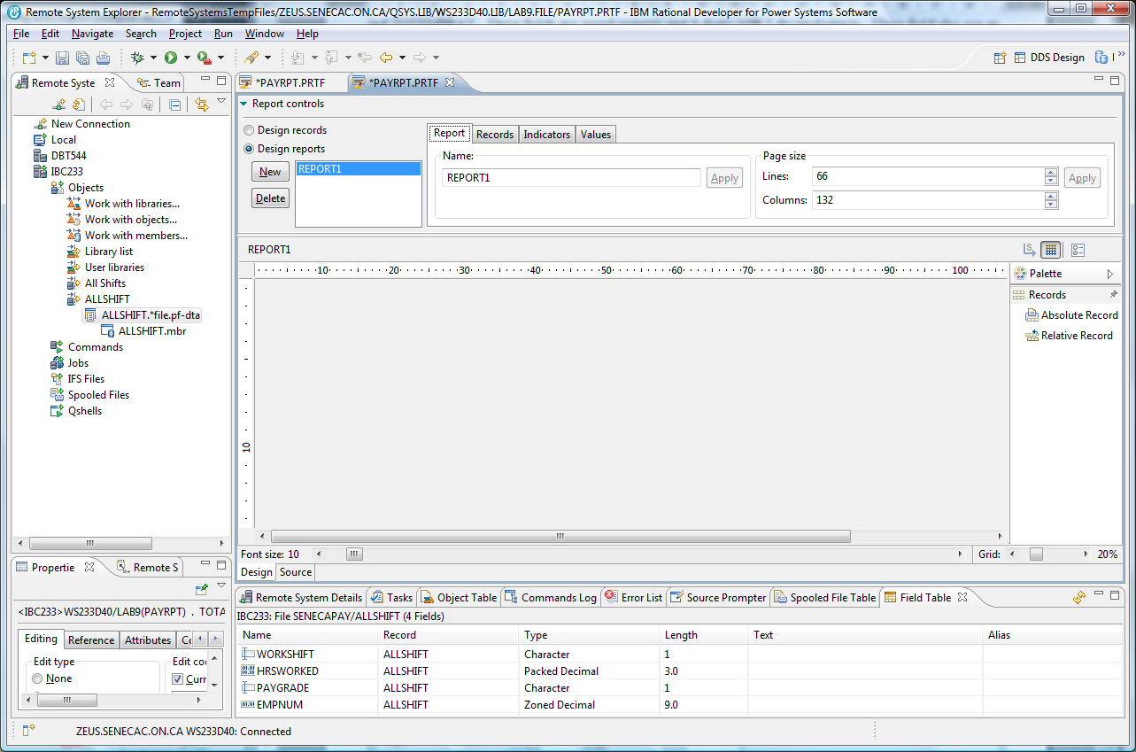

Click on the Records tab and use the Add button to add one record at a time in the proper order.
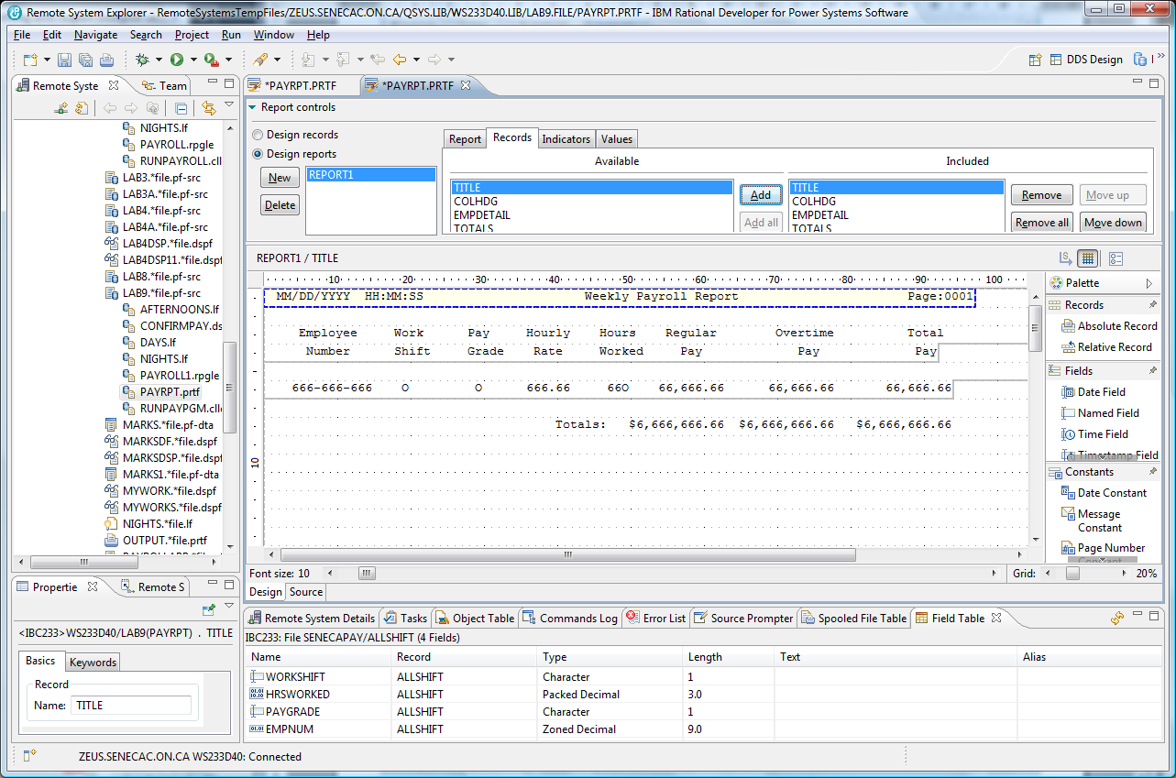

When you have added all the records, you can adjust where the fields line up or where the column headings line up by clicking on the record content.

After you have moved everything around so it appears similar to the last screenshot shown, save your work so it can be viewed by an instructor.

Your last step is to compile the DDS code that has been generated for you.

Click on the SOURCE tab in the DESIGN/SORUCE area and then using the top menu compile option with the CRTPTF command.

A successful compile produces an externally described file in your library that can be used by programs.

Object Type Attribute

PAYRPT *FILE PRTF

Any programmer can refer to this file in their program and they are relieved of entering the code that describes how the report will appear.

